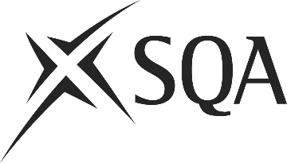

SCOTTISH QUALIFICATIONS AUTHORITY
DANGEROUS GOODS SAFETY ADVISER EXAMINATIONS
Examination centres for 13th June 2024

ABERDEEN | BELFAST
Centre No: TBC | Centre No: TBC
BIRMINGHAM | BRISTOL
Centre No: TBC | Centre No: TBC
HULL / YORK | MANCHESTER
Centre No: TBC | Centre No: TBC
MIDDLESBROUGH | NORTHAMPTON
Centre No: TBC | Centre No: TBC
STIRLING | SURREY
Centre No: TBC | Centre No: TBC
Candidates must give a second choice of venue on their application form as their first choice may not be available.

Please note that the availability of venues is dependent on the number of candidates. This list is not a complete list of approved centres. Other centres have demonstrated that they meet our approval criteria and may be used if the number of candidates makes this necessary.

SQA will adjust the number and location of venues based on the number of candidates. If candidate applications exceed the capacity of venues, SQA will try to ensure that you are allocated to a centre in the next closest town or city to your first choice.

All enquiries about the examinations should be made to SQA and NOT the examination centres.

